# **Task4.**

# **Project: OLAP Operations (using Redshift or PostgreSQL)**

*CREATE DATABASE "Sales Data "*

*WITH*

*OWNER = postgres*

*ENCODING = 'UTF8'*

*LC_COLLATE = 'English_United States.1252'*

*LC_CTYPE = 'English_United States.1252'*

*TABLESPACE = pg_default*

*CONNECTION LIMIT = -1*

*IS_TEMPLATE = False;*

**1) Database creation**

CREATE TABLE Sales_sample (Product_Id INT, Region VARCHAR(50), On_date DATE,

Sales_Amount NUMERIC);

**2) Data Creation**

|  |  |
| --- | --- |
| INSERT INTO Sales_sample (Product_Id, Region, On_date, Sales_Amount) VALUES  ('1', 'East', '2023-10-10', '20000'),  ('2', 'West', '2023-09-19', '50000'),  ('2', 'East', '2023-10-21', '40000'),  ('3', 'North', '2023-09-20', '15000'),  ('4', 'North', '2023-08-06', '45000'),  ('2', 'South', '2023-08-25', '45000'),  ('5', 'North', '2023-11-23', '20000'),  ('5', 'West', '2023-11-11', '60000'),  ('3', 'East', '2023-09-19', '50000'),  ('1', 'West', '2023-09-29', '70000');  Select * from Sales_Sample; |  |

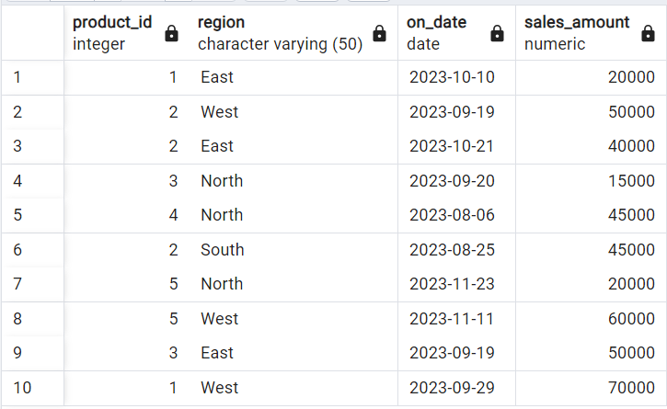

**3) OLAP operations**

a) Drill down

SELECT Region, Product_Id, Sum(Sales_Amount) AS Sales_Amount

FROM Sales_Sample

GROUP BY 1,2

ORDER BY Region, Product_Id, Sales_Amount;

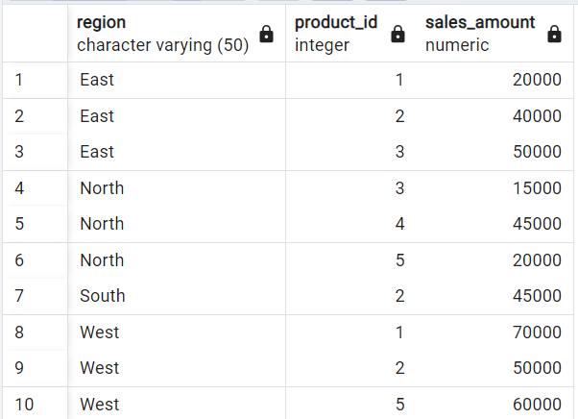

b) Roll Up

*SELCT Region, Product_Id, Sum(Sales_Amount) AS Sales_Amount*

*FROM Sales_Sample*

*GROUP BY ROLLUP (1,2)*

*ORDER BY Region;*

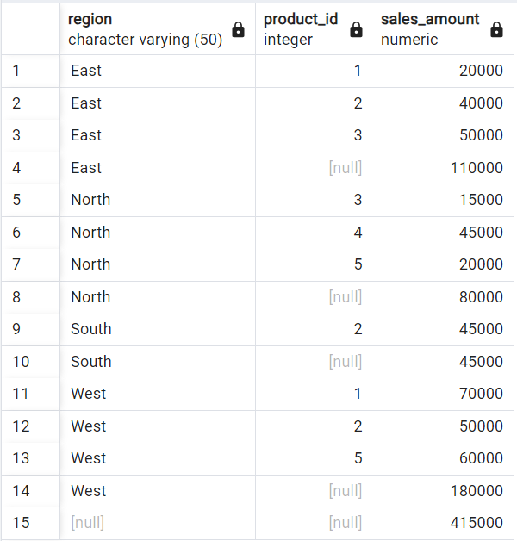

c) Cube

*SELECT Region, Product_Id, On_Date, SUM(Sales_Amount) AS Sales_Amount*

*FROM Sales_Sample*

*GROUP BY Cube (1,2,3)*

*ORDER BY Region, Product_Id, On_Date, Sales_Amount;*

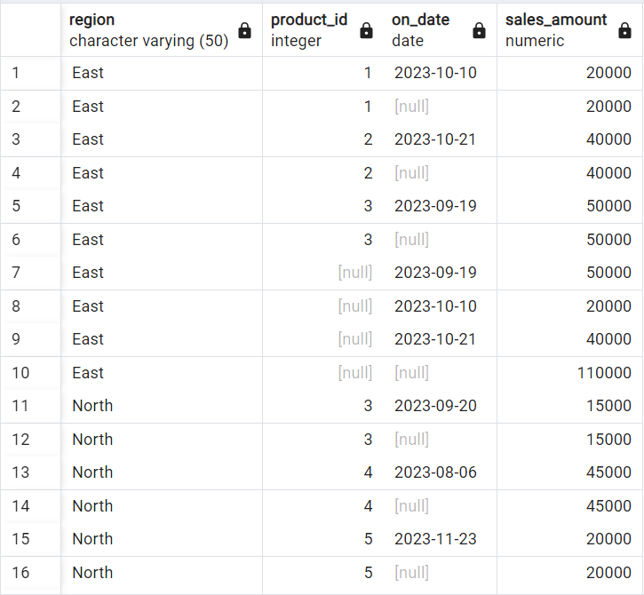

d) Slice

*SELECT Region, Product_Id, On_Date, SUM(Sales_Amount) AS Sales_Amount*

*FROM Sales_Sample*

*WHERE Region in('North', 'South') OR On_Date BETWEEN To_date('2023-08-20','YYYY-MM-DD') AND To_Date('2023-10-20','YYYY-MM-DD')*

*GROUP BY 1,2,3*

*ORDER BY Region, Product_Id, On_Date, Sales_Amount;*

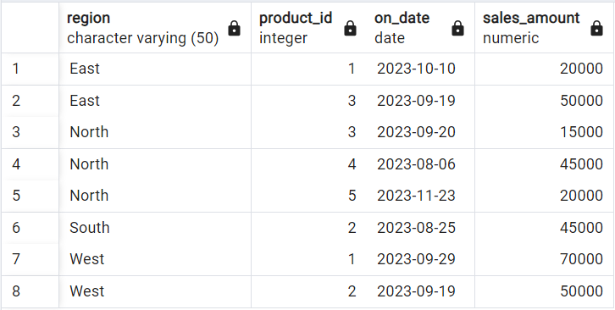

e) Dice

*SELECT Region, Product_Id, On_Date, SUM(Sales_Amount) AS Sales_Amount*

*FROM Sales_Sample*

*WHERE Region in('North', 'South') AND Product_Id IN (1,2) AND On_Date BETWEEN To_date('2023-08-20','YYYY-MM-DD') And To_Date('2023-10-20','YYYY-MM-DD')*

*GROUP BY 1,2,3*

*ORDER BY Region, Product_Id, On_Date, Sales_Amount;*

